LECTURE 6
PROCESSES AND THREADS

1. Introduction to Processes
1.1 What is a Process?
Definition of a Process
A process is an instance of a program that is currently executing.
It is not just a program stored on disk.
It is the program in execution along with all the resources it needs to run.
For example:
- A program saved on disk is just a file.
- When that program is opened and running, it becomes a process.
Why Process Abstraction is Necessary
A computer runs many programs at the same time. For example:
- Browser
- Media player
- Background services
However, the CPU can execute only one instruction at a time (on a single core).
To manage multiple running programs efficiently, the operating system uses the concept of a process.
The process abstraction helps to:
- Separate different running programs
- Manage CPU time properly
- Prevent programs from interfering with each other
- Create a structured execution environment
Without the process concept, managing multiple tasks would be very complex.
Components of a Process
A process consists of the following main components:
- Program Code
The actual instructions that need to be executed.
- Program Counter (PC)
Stores the address of the next instruction to execute.
- CPU Registers
Hold temporary data and intermediate results during execution.
- Variables
Includes local variables and global variables used by the program.
- Input/Output Information
Open files, devices, or network connections used by the process.
- Process State
Indicates the current status of the process (such as running or waiting).
All these together form a complete process.
1.2 The Process Model
The process model explains how an operating system manages multiple programs using a single CPU.
Assume there are four programs in memory:
A, B, C, and D.
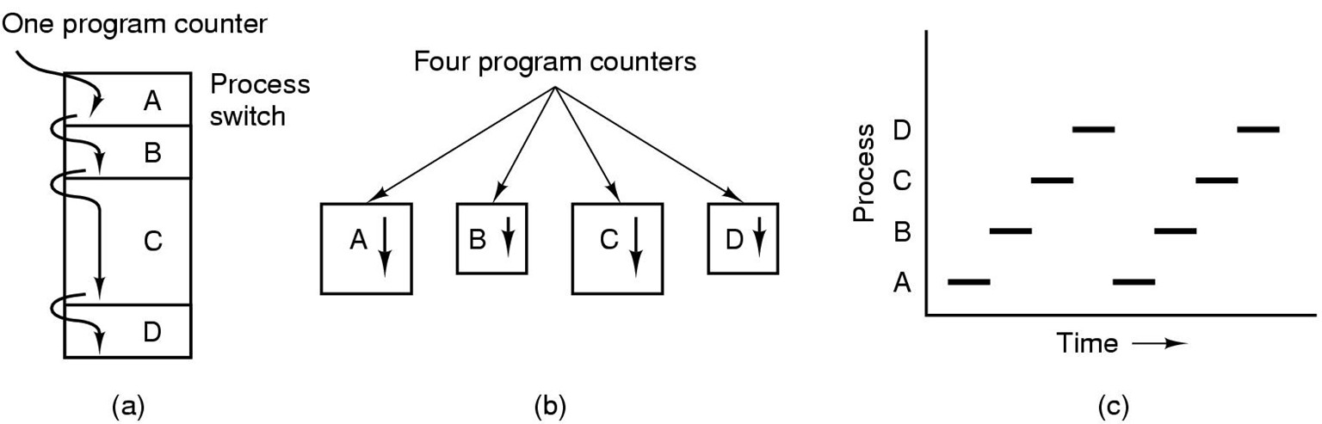
1. Multiprogramming of Four Programs
In multiprogramming:
- Multiple programs are kept in memory at the same time.
- The CPU does not wait if one program is blocked (for example, waiting for disk or keyboard).
- Instead, it switches to another program.
Example flow:
- CPU runs Process A.
- A requests disk input and must wait.
- CPU switches to Process B.
- After B uses its time slice, CPU switches to C.
- Then to D.
- When A is ready again, CPU returns to A.
This switching ensures:
- The CPU is never idle.
- System performance improves.
- Resources are used efficiently.
This is the basic idea of multiprogramming.
2. Only One Program Active at Any Instant
Even though four programs are loaded and ready:
- The CPU can execute only one instruction at a time (in a single-core system).
- Therefore, only one process is active at any exact instant.
The time diagram shows this clearly:
- A runs for a short time.
- Then B runs.
- Then C runs.
- Then D runs.
- Then back to A again.
So the pattern becomes:
A → B → C → D → A → B → C → D …
Each process gets a small portion of CPU time called a time slice.
This rapid switching is called context switching.
Because switching is very fast, users feel that all programs are running simultaneously, but technically they are not.
3. Conceptual Model of Four Independent Sequential Processes
Although the CPU keeps switching between processes, we logically treat each process as independent.
Conceptually:
- Each process has its own program counter.
- Each process executes instructions sequentially.
- Each process progresses independently of others.
For example:
- Process A continues from where it stopped when it gets CPU again.
- Process B also continues from its own last instruction.
- Same for C and D.
From a logical point of view:
It looks as if there are four separate CPUs, one for each process.
But in reality:
- There is only one physical CPU.
- The operating system creates the illusion of parallel execution.
Overall Flow of the Process Model
- Multiple programs are loaded into memory.
- CPU runs one process at a time.
- It switches rapidly between processes.
- Each process behaves as an independent sequential unit.
- This creates the illusion that all processes are running simultaneously.
This combination of:
- Multiprogramming
- Time sharing
- Context switching
- Independent sequential execution
forms the complete Process Model.

2. Process Management
Process management refers to how the operating system creates, controls, and terminates processes during system operation.
2.1 Process Creation
A process is not created randomly. Certain events cause the operating system to create a new process.
The main situations are:
1. System Initialization
When the computer starts (booting process):
- The operating system is loaded into memory.
- Several system processes are automatically created.
Examples:
- Background services
- Login manager
- Device managers
These processes are necessary for the system to function properly.
So, during system startup, many essential processes are created automatically.
2. Process Creation System Call
A running process can create a new process using a system call.
This is called a process creation system call.
Example (conceptually):
- In UNIX: fork()
- In Windows: CreateProcess()
How it works:
- A parent process makes a system call.
- The OS creates a new child process.
- The child process gets its own memory space and program counter.
- The parent and child can run independently.
This forms a parent–child relationship between processes.
3. User Request
A process can also be created when a user starts a program.
Example:
- Double-clicking a browser icon.
- Running a program from the command line.
In this case:
- User requests execution.
- OS loads the program into memory.
- A new process is created.
- Execution begins.
So every time a user opens an application, a new process is created.
4. Batch Job Initiation
In batch processing systems:
- Jobs are submitted in advance.
- The system executes them one by one without user interaction.
When a batch job starts:
- The operating system creates a process for that job.
- It runs automatically.
- After completion, it terminates.
This is common in large systems and servers.
2.2 Process Termination
Just as processes are created, they must also end. A process can terminate in several ways.
1. Normal Exit (Voluntary)
This happens when:
- A process finishes its task successfully.
- It calls an exit system call.
Example:
- A program completes its work and closes normally.
This is the correct and expected way of termination.
2. Error Exit (Voluntary)
Sometimes a process detects an error and decides to terminate itself.
Example:
- Invalid input detected.
- Required file not found.
In this case:
- The program prints an error message.
- It exits by itself.
It is still voluntary because the process chooses to terminate.
3. Fatal Error (Involuntary)
A fatal error occurs due to serious problems such as:
- Illegal memory access
- Division by zero
- Protection violation
In this case:
- The operating system forces the process to terminate.
- The process does not choose to exit.
This is involuntary termination.
4. Killed by Another Process (Involuntary)
A process can be terminated by another process.
Example:
- A parent process kills a child process.
- A user uses a command to force-stop a program.
In this case:
- The process does not terminate by itself.
- It is forcibly terminated by an external entity.
This is also involuntary termination.
2.3 Process Hierarchies
When processes are created, they often form relationships.
These relationships create a hierarchy among processes.
Parent and Child Processes
When a process creates another process using a system call:
- The original process is called the parent process.
- The newly created process is called the child process.
The child process:
- Has its own memory space.
- Has its own program counter.
- Executes independently.
- May run the same program as the parent or a different one.
Important points:
- A parent can create multiple child processes.
- A child process can also create its own child.
- This creates multiple levels of processes.
Example flow:
- Process A creates Process B.
- Process B creates Process C.
- Process C creates Process D.
Now A is the parent of B,
B is the parent of C,
C is the parent of D.
This forms a hierarchical structure.
Process Tree
Because processes create other processes, they form a tree structure called a process tree.
In a process tree:
- The first process (created at system startup) is the root.
- Every other process is a descendant of that root.
- Each process (except the root) has exactly one parent.
The structure looks like a tree:
Root
├── Child 1
│ ├── Grandchild 1
│ └── Grandchild 2
└── Child 2
This hierarchy helps the operating system:
- Track process relationships
- Manage resource sharing
- Control termination of child processes
For example:
If a parent process terminates, the OS may also handle its child processes accordingly.
UNIX Process Groups
In UNIX systems:
- Processes are organized in a hierarchy.
- Every process (except the first one) has a parent.
- All processes ultimately originate from the initial system process.
UNIX also supports process groups:
- A process group is a collection of related processes.
- Usually, processes created from the same program belong to the same group.
- Signals (like terminate or interrupt) can be sent to the entire group.
This makes it easier to:
- Control multiple related processes
- Manage jobs in the shell
UNIX strongly follows the hierarchical model.
Windows Process Model
In Windows:
- Processes are also created by other processes.
- However, Windows does not strictly enforce a hierarchical process tree like UNIX.
Key differences:
- Windows does not treat processes as tightly structured parent-child hierarchies.
- Processes are considered more independent.
- Once created, a process does not rely heavily on its parent.
So:
UNIX → Strong hierarchical model
Windows → Processes are more independent and equal

3. Process States and State Transitions
A process does not stay in one condition forever.
During its lifetime, it moves through different states.
These states show what the process is currently doing.
3.1 Basic Process States
The main process states are:
1. New
- The process is being created.
- The operating system is setting up its data structures.
- Memory and resources are being allocated.
At this stage, the process is not yet ready to run.
2. Ready
- The process is prepared to run.
- It is waiting for CPU allocation.
- All required resources are available except the CPU.
There may be many processes in the Ready state.
The scheduler selects one of them to execute.
3. Running
- The process is currently executing on the CPU.
- Its instructions are being processed.
In a single-core system:
- Only one process can be in the Running state at a time.
4. Waiting / Blocked
- The process cannot continue execution.
- It is waiting for an external event.
Common reasons:
- Waiting for disk I/O
- Waiting for keyboard input
- Waiting for network data
- Waiting for a signal
- Waiting for a child process
While in this state:
- The CPU does not execute this process.
- Another process is scheduled instead.
5. Terminated
- The process has finished execution.
- It has either completed normally or was stopped.
- The OS removes it from memory after cleanup.
This is the final state of a process.
3.2 State Transitions
A process moves from one state to another due to certain events.
Running → Blocked
This happens when:
- The process requests something that is not immediately available.
- It must wait for I/O or some external event.
Example:
- A process reads a file.
- Disk operation takes time.
- Process moves to Blocked state.
When the I/O finishes:
- The process moves back to Ready state.
Running → Waiting
In many systems, Waiting and Blocked mean the same thing.
But sometimes Waiting is used for:
- Waiting for a signal
- Waiting for a child process (e.g., wait() call)
- Waiting for a resource like a semaphore or mutex
In both cases:
- The process cannot continue.
- CPU is given to another process.
Ready → Running
This transition happens when:
- The scheduler selects a process from the Ready queue.
- The CPU is assigned to it.
The process begins execution.
Interrupt-Based Transitions
Interrupts play an important role in state changes.
Example:
- A process is Running.
- A timer interrupt occurs.
- The OS stops the current process.
- It moves back to Ready state.
- Another process is scheduled.
Interrupts ensure:
- Fair CPU sharing.
- Proper time slicing.
- Responsive system behavior.
3.3 Process States as a Finite State Machine (FSM)
Definition of Finite State Machine (FSM)
A Finite State Machine is a model that:
- Has a limited number of states.
- Moves from one state to another.
- Changes state based on events or inputs.
- At any moment, it is in only one state.
Process States Modeled as FSM
Process states form a Finite State Machine because:
- There are limited states: New, Ready, Running, Waiting, Terminated.
- A process can be in only one state at a time.
- Specific events cause transitions between states.
Example:
New → Ready → Running → Waiting → Ready → Running → Terminated
Each arrow represents a state transition.
Role of Interrupts in State Changes
Interrupts are events that trigger state transitions.
Types of interrupts that affect processes:
- Timer interrupt
  - Moves Running process back to Ready.
  - Allows CPU to switch processes.
- I/O completion interrupt
  - Moves Waiting process to Ready.
  - Process can now execute again.
Interrupts allow the operating system to:
- Control CPU scheduling.
- Handle I/O efficiently.
- Maintain the process state machine properly.

4. Process Implementation in Operating System
This diagram explains what happens inside the operating system when an interrupt occurs and the CPU switches from one process to another.
It shows the low-level steps performed by hardware and the OS.
What Happens During an Interrupt
When an interrupt occurs (for example, timer interrupt or I/O completion), the following sequence happens:
1. Hardware Saves Current State
The hardware automatically:
- Saves the current program counter (PC)
- Saves important CPU information
This ensures the current process can resume later from the same point.
2. Hardware Loads New Program Counter
- The CPU loads a new program counter from the interrupt vector.
- This transfers control to the interrupt handler.
The interrupt vector contains addresses of interrupt service routines.
3. Assembly Code Saves Registers
The interrupt handler (written in assembly):
- Saves CPU registers of the current process.
- Stores them in the process control block (PCB).
This is part of context saving.
4. Assembly Sets Up New Stack
The system:
- Switches to a kernel stack.
- Prepares a safe execution environment for OS code.
5. Interrupt Service Routine Executes
Now the C-level interrupt service routine runs.
It may:
- Read input
- Buffer data
- Handle I/O completion
- Update process state
6. Scheduler Chooses Next Process
After handling the interrupt:
- The scheduler decides which process should run next.
- It may choose:
  - The same process
  - Or a different ready process
7. Return to Assembly Code
Control returns to assembly code.
The system prepares to restore the selected process.
8. Start the New Process
Finally:
- The assembly code restores registers of the selected process.
- The program counter is restored.
- The CPU resumes execution of that process.
This is called a context switch.

CPU Utilization
What is CPU Utilization?
CPU Utilization is the percentage of time the CPU is busy doing useful work.
If the CPU is always executing processes → utilization is high.
If the CPU is idle most of the time → utilization is low.
The goal of multiprogramming is to increase CPU utilization.
Why CPU Becomes Idle
A process is not always using the CPU.
Sometimes it waits for:
- Disk I/O
- Keyboard input
- Network data
- Printer
When a process is waiting for I/O, it is blocked.
During this time, the CPU may become idle if there are no other ready processes.
CPU Utilization Formula
The formula shown is:
CPU Utilization = 1 − Pⁿ
Where:
- P = Probability that a process is waiting for I/O
- n = Number of processes in memory
Meaning:
If all processes are waiting for I/O at the same time, the CPU becomes idle.
Pⁿ represents the probability that all n processes are waiting.
So:
1 − Pⁿ gives the probability that at least one process is ready to use the CPU.
That is the CPU utilization.
0
20
40
60
80
100
120
CPU Utilization in %age
20
% I/O
40
% I/O
% I/O
60
80
% I/O
Understanding the Graph
The graph shows:
- X-axis → Number of Processes
- Y-axis → CPU Utilization (%)
- Different curves → Different I/O percentages (20%, 40%, 60%, 80%)
Case 1: 20% I/O (Low I/O Processes)
If processes wait only 20% of the time:
- Even with few processes, CPU utilization becomes very high.
- With 3–4 processes, utilization approaches 100%.
Reason:
Low I/O means processes are CPU-bound.
So the CPU is almost always busy.
Case 2: 40% I/O
Processes spend 40% time waiting.
- CPU utilization increases as number of processes increases.
- Around 6–8 processes give near full utilization.
More processes reduce idle time.
Case 3: 60% I/O
Processes spend more time waiting.
- With only 1 process → utilization is low.
- As we increase number of processes → utilization improves gradually.
- Around 10+ processes are needed for high utilization.
Case 4: 80% I/O (Highly I/O Bound)
Processes wait 80% of the time.
- With 1 process → CPU utilization is very low.
- Even with several processes, utilization increases slowly.
- Many processes are required to keep CPU busy.
Reason:
Most processes are blocked most of the time.

5. Threads
Threads are a fundamental concept used to improve performance and responsiveness in modern systems.
5.1 Introduction to Threads
Definition of a Thread
A thread is the smallest unit of execution inside a process.
A process can contain multiple threads.
Each thread performs a task within the same process.
Important idea:
A process is a resource container, and threads are the execution units inside it.
Thread vs Process
Although both are execution units, they are different.
Process
- Has its own separate memory space.
- More heavyweight.
- Creating a process is slower.
- Communication between processes is more complex.
Thread
- Exists inside a process.
- Shares memory with other threads of the same process.
- Lightweight.
- Faster to create and switch.
Key Difference:
Processes are independent from each other.
Threads inside the same process are dependent and share resources.
Shared vs Private Resources
Threads inside the same process share some resources but also have private components.
Shared Resources (common to all threads in a process)
- Code (program instructions)
- Global variables (data section)
- Heap memory (dynamic memory)
- Open files
- Network connections
- Other system resources
Because they share memory, threads can communicate easily.
Private Resources (unique to each thread)
Each thread has:
- Its own program counter
- Its own stack
- Its own register set
This allows each thread to execute independently.
5.2 Thread Structure
Inside a multithreaded process:
Each Thread Has
1. Program Counter
- Stores the address of the next instruction.
- Allows the thread to continue from where it stopped.
Each thread has its own program counter because each thread may be executing different parts of the program.
2. Stack
The stack stores:
- Local variables
- Function parameters
- Return addresses
Each thread must have its own stack to avoid interfering with other threads.
All Threads Share
1. Code Section
- The same program instructions are shared.
2. Data Section
- Global variables are shared.
- Changes by one thread can be seen by others.
3. Heap
- Dynamically allocated memory is shared.
4. Open Files
- File descriptors are common to all threads.
5. Other Resources
- Sockets
- Signals
- Other OS resources
This shared environment makes communication easy but may cause race conditions if not handled properly.
5.3 Thread Example (Restaurant Analogy)
To understand threads easily, consider a restaurant.
Process = The Restaurant
Threads = The Workers
The restaurant (process):
- Has one kitchen
- Has ingredients
- Has equipment
- Has space
All workers (threads):
- Share the same kitchen
- Share the same ingredients
- Share the same equipment
But:
- Each worker does a different task.
- Each worker works independently.
- Each worker has their own order list (like a thread’s stack and program counter).
If one worker is waiting for food to cook, another worker can continue working.
This improves efficiency and speed.

6. Thread Usage
Threads are used to improve performance, responsiveness, and efficient resource utilization in applications.
6.1 Multithreaded Applications
Many modern applications use multiple threads to perform different tasks simultaneously within the same process.
Word Processor Example
A word processor is a good example of a multithreaded application.
It may use separate threads for:
- Editing Thread
  - Handles typing and user input.
- Spell-Check Thread
  - Checks spelling and grammar in the background.
- Auto-Save Thread
  - Periodically saves the document.
Why use multiple threads?
- While the user is typing, spell-check can run in the background.
- Auto-save does not interrupt typing.
- The application remains responsive.
If it were single-threaded:
- The system might freeze while spell-checking or saving.
Web Server Example
A web server handles requests from many clients at the same time.
In a multithreaded web server:
- Each incoming request is handled by a separate thread.
- Multiple clients can be served simultaneously.
Example flow:
- Client A sends a request.
- Server creates or assigns a thread to handle A.
- Client B sends a request.
- Another thread handles B.
- If one request is waiting for disk I/O, others continue processing.
This improves:
- Performance
- Throughput
- Response time
6.2 Dispatcher and Worker Threads
In many multithreaded systems, threads are organized into roles.
Dispatcher Thread
The dispatcher thread:
- Waits for incoming requests.
- Accepts connections.
- Assigns work to worker threads.
It does not perform heavy processing.
Its job is coordination.
Worker Threads
Worker threads:
- Perform the actual work.
- Process requests.
- Execute tasks.
For example, in a web server:
- Dispatcher accepts a client connection.
- Worker thread processes the client’s request.
This separation improves efficiency and scalability.
6.3 Three Ways to Construct a Server
There are three main designs for building a server.
1. Single-Threaded Server
- Only one thread handles all requests.
- One request is processed at a time.
If one request blocks (e.g., waiting for disk):
- The entire server blocks.
Advantages:
- Simple to design.
- Easy to implement.
Disadvantages:
- Poor performance.
- Not scalable.
2. Multi-Process Server
- Each request is handled by a separate process.
- Multiple processes run independently.
Advantages:
- Strong isolation between requests.
- One process crashing does not affect others.
Disadvantages:
- Creating processes is expensive.
- Higher memory usage.
- Slower context switching.
3. Multi-Threaded Server
- One process with multiple threads.
- Each request handled by a separate thread.
Advantages:
- Lightweight compared to processes.
- Faster creation and switching.
- Shared memory allows easy communication.
- Better performance than single-threaded.
Disadvantages:
- Requires synchronization.
- Risk of race conditions.

7. The Thread Model
The thread model explains how threads are organized inside processes and how they share or separate resources.
It compares:
- One thread per process
- Multiple threads inside one process
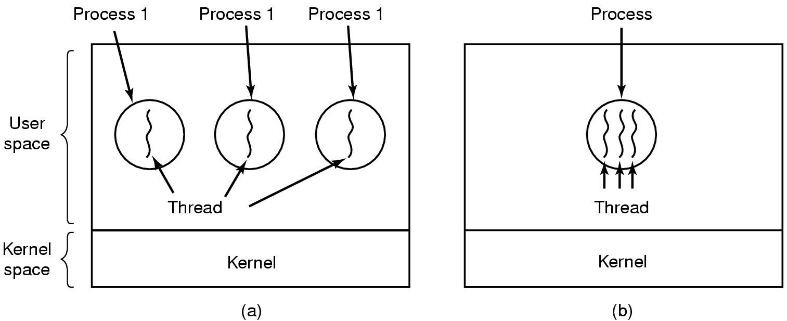
7.1 One Thread per Process
In this model:
- Each process contains only one thread.
- The process itself is the execution unit.
Characteristics:
- One program counter
- One stack
- One execution path
- No internal parallelism
If the process blocks (for example, waiting for I/O):
- The entire process stops.
- No other task inside it can continue.
This is similar to traditional single-threaded programs.
Example:
A simple program that:
- Takes input
- Processes it
- Produces output
- Does everything sequentially
There is no internal concurrency.
7.2 Multiple Threads in One Process
In this model:
- A single process contains multiple threads.
- Each thread performs a different task.
- All threads share the same memory space.
Characteristics:
- Multiple program counters
- Multiple stacks
- Multiple execution paths
- Shared code and data
Advantages:
- One thread can continue while another waits.
- Better CPU utilization.
- Improved responsiveness.
Example:
A web server process:
- Thread 1 handles client A.
- Thread 2 handles client B.
- Thread 3 handles logging.
- Thread 4 handles database queries.
All inside the same process.
7.3 Shared vs Private Thread Data
In a multithreaded process, some data is shared and some is private.
Shared Data (common to all threads)
- Code (program instructions)
- Global variables
- Heap memory (dynamic allocation)
- Open files
- Signals
- Other system resources
Because memory is shared:
- Threads can communicate easily.
- But synchronization is required to avoid race conditions.
Private Data (unique to each thread)
Each thread has:
- Its own program counter
- Its own CPU registers
- Its own stack
This allows each thread to:
- Execute independently
- Call different functions
- Maintain its own local variables
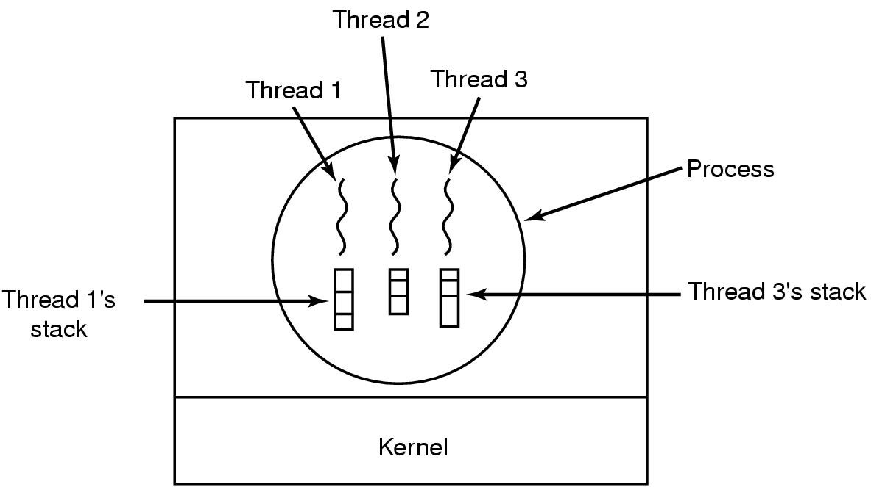
7.4 Each Thread’s Stack
Each thread must have its own stack.
The stack stores:
- Local variables
- Function parameters
- Return addresses
Why separate stacks are necessary:
If threads shared the same stack:
- Function calls would interfere.
- Local variables would overwrite each other.
- Execution would become incorrect.
So even though threads share memory, their stacks must remain separate.
Example:
Thread A calls function f().
Thread B calls function g().
Each thread needs its own stack to store:
- Its own function calls
- Its own local variables
This ensures correct independent execution.
8. POSIX Threads (Pthreads)
POSIX Threads (Pthreads) is a standard API used in UNIX/Linux systems for creating and managing threads in C programs.
1. pthread_create
Purpose: Create a new thread.
- It starts a new thread inside the same process.
- The new thread begins execution from a specified function.
- Both the main thread and the new thread run concurrently.
This is the basic function used to introduce multithreading in a program.
2. pthread_exit
Purpose: Terminate the calling thread.
- It ends the execution of the current thread.
- Other threads in the process continue running.
- It does not terminate the whole process unless it is the last thread.
Used when a thread finishes its task.
3. pthread_join
Purpose: Wait for a specific thread to exit.
- One thread waits for another thread to finish.
- Ensures synchronization between threads.
- Commonly used so the main thread waits for worker threads.
Without pthread_join, a program might exit before worker threads complete.
4. pthread_yield
Purpose: Release the CPU voluntarily.
- The calling thread gives up the CPU.
- The scheduler can run another ready thread.
- The thread remains in the ready state.
Useful for cooperative multitasking.
5. pthread_attr_init
Purpose: Initialize a thread attribute structure.
- Used to set properties of a thread before creation.
- Examples of attributes:
  - Stack size
  - Scheduling policy
  - Detach state
It prepares configuration settings for a new thread.
6. pthread_attr_destroy
Purpose: Remove a thread’s attribute structure.
- Cleans up the attribute object.
- Frees resources associated with thread attributes.
Used after the attributes are no longer needed.

9. Thread Implementation Models
Threads can be implemented in different ways depending on who manages them — the user-level library or the operating system kernel.
9.1 User-Level Threads (ULT)
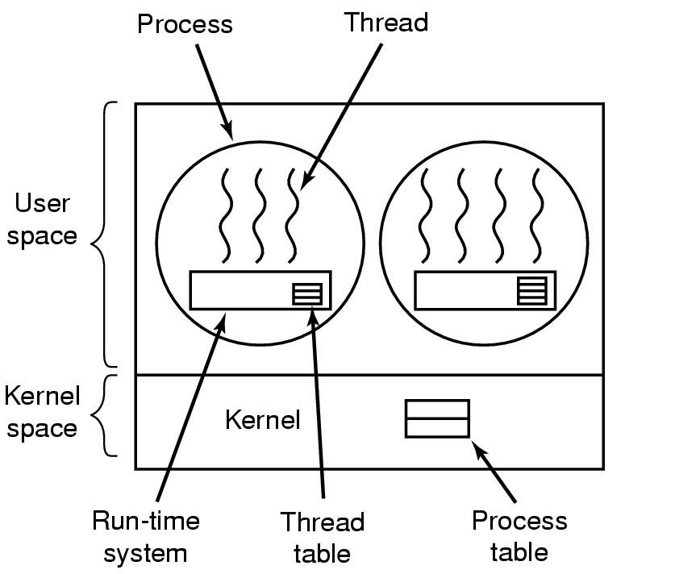
Managed in User Space
In User-Level Threads:
- Threads are managed by a user-level library.
- The kernel does not know about individual threads.
- To the kernel, the process appears single-threaded.
- Thread scheduling is done by the thread library, not the OS.
All thread operations (create, switch, terminate) happen in user space.
Advantages of ULT
- Fast thread creation
No system call is needed.
- Fast context switching
Switching between threads does not require kernel involvement.
- Portable
Can run on operating systems that do not support kernel threads.
- Flexible scheduling
The application can use its own scheduling algorithm.
Disadvantages of ULT
- Blocking problem
If one thread performs a blocking system call, the entire process blocks.
- No true parallelism
On multi-core systems, only one thread can run at a time because the kernel sees only one process.
- Kernel is unaware of threads
The OS cannot schedule threads individually.
Example
Imagine a simple chat application.
- The application creates 5 threads:
  - Thread 1: Receive messages
  - Thread 2: Send messages
  - Thread 3: Save chat history
  - Thread 4: Update UI
  - Thread 5: Handle notifications
All these threads are managed by a user-level thread library.
Now suppose:
- Thread 1 calls a blocking system call to read from the network.
- Since the kernel sees only one process (not multiple threads),
- The entire process blocks.
So even though other threads are ready, none can run.
This shows the main weakness of ULT.
9.2 Kernel-Level Threads (KLT)
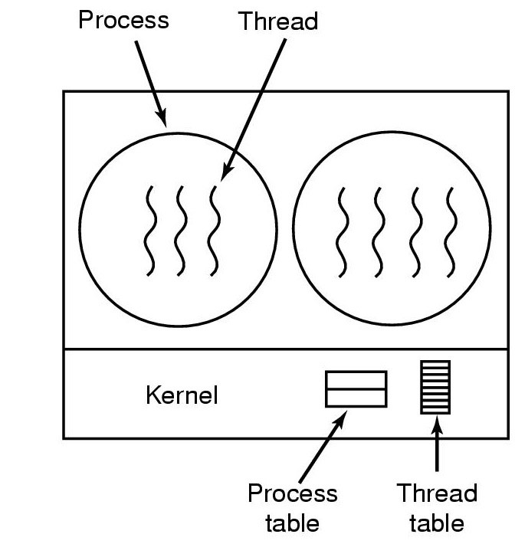
Managed by Kernel
In Kernel-Level Threads:
- The operating system kernel manages threads.
- The kernel knows about each thread.
- Each thread is scheduled independently.
Thread operations require system calls.
Advantages of KLT
- True parallelism
Multiple threads can run simultaneously on multiple CPU cores.
- Better blocking behavior
If one thread blocks, others in the same process can continue.
- Kernel-level scheduling
The OS can manage thread priorities and scheduling directly.
Disadvantages of KLT
- Slower creation
System calls are required.
- Slower context switching
Switching involves kernel intervention.
- Higher overhead
More resource usage compared to user-level threads.
Example
Imagine a web browser on a multi-core system.
The browser creates multiple threads:
- Thread 1: Load webpage
- Thread 2: Play video
- Thread 3: Handle user input
- Thread 4: Background download
Each thread is managed by the operating system kernel.
Now suppose:
- Thread 1 waits for network data.
- The kernel blocks only Thread 1.
- Threads 2, 3, and 4 continue running.
- On a 4-core CPU, they may even run truly in parallel.
This shows the advantage of KLT:
True parallelism and better handling of blocking.
9.3 Hybrid Thread Model
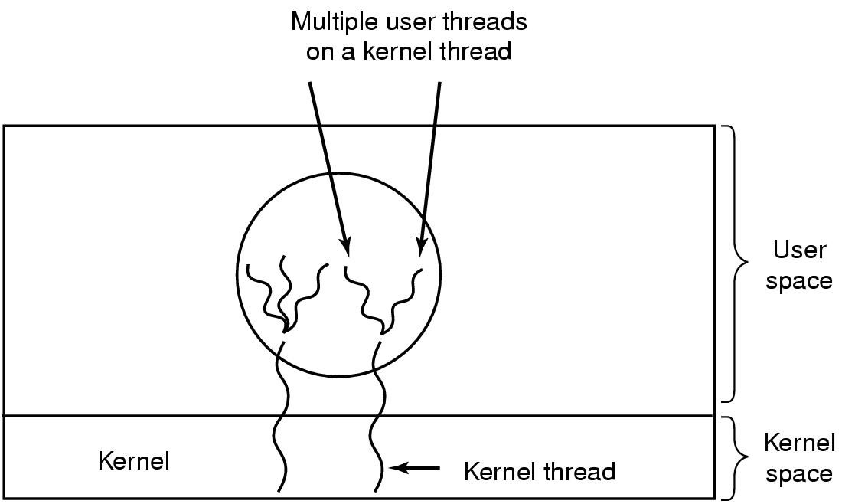
Multiplexing ULT onto KLT
The Hybrid model combines both approaches.
- Multiple user-level threads are mapped onto one or more kernel-level threads.
- The user-level library manages many threads.
- The kernel schedules a smaller number of kernel threads.
This is often called the Many-to-Many model.
Advantages:
- Combines flexibility of ULT
- Gains parallelism of KLT
It reduces some disadvantages of both models.
Example
Assume:
- 4 User-Level Threads: U1, U2, U3, U4
- 2 Kernel-Level Threads: K1, K2
- 2 CPU cores
Many user threads are mapped onto fewer kernel threads.
Step 1: Threads Start Running
Initially:
- K1 is assigned U1
- K2 is assigned U2
Both CPU cores are busy.
U3 and U4 are waiting in the ready queue (user-level queue).
Step 2: One Thread Blocks
Now suppose:
- U2 requests disk I/O.
- Since it is a blocking system call, K2 becomes blocked in the kernel.
At this moment:
- K1 continues running U1.
- K2 cannot execute anything until the disk operation completes.
- U3 and U4 are still ready at user level.
Step 3: Scheduler Reassigns Work
After U1’s time slice ends:
- The user-level thread library assigns U3 to K1.
Now:
- K1 runs U3.
- K2 is still blocked.
- U4 remains in the ready queue.
The system is still partially active because one kernel thread is working.
Step 4: Blocking Ends
When U2’s disk operation completes:
- K2 becomes free again.
- The user-level scheduler assigns U4 to K2.
Now:
- K1 runs U3.
- K2 runs U4.
Both CPU cores are active again.
9.4 Scheduler Activations
Scheduler Activations are designed to combine:
- Performance of user-level threads
- Functionality of kernel-level threads
Goal
The goal is:
- Allow the user-level thread library to manage threads.
- While still allowing the kernel to control CPU allocation.
It avoids unnecessary user-kernel transitions.
Virtual Processors
In this model:
- The kernel assigns virtual processors to a process.
- A virtual processor acts like a CPU assigned to that process.
- The user-level thread library schedules threads onto these virtual processors.
So:
Kernel controls how many CPUs the process gets.
User-level library decides which thread runs on each CPU.
Problems
- Complexity
The design is complicated.
- Tight cooperation needed
Requires coordination between kernel and user space.
- Implementation difficulty
Hard to implement efficiently.
Because of these issues, it is not widely used today.
9.5 Pop-Up Threads
Pop-Up Threads are created automatically in response to an event.
Characteristics:
- Created when needed.
- Used for short tasks.
- Improve responsiveness.
Common in network servers and event-driven systems.
Example
Imagine a mail server.
- A new email arrives.
- The system automatically creates a temporary thread to process that email.
- The thread:
  - Scans for spam
  - Stores the email
  - Sends notification
- After finishing, the thread terminates.
Each incoming message creates a new short-lived thread.
These are pop-up threads because:
- They are created automatically.
- They exist only to handle a specific event.
- They disappear after completing the task.

10. Interprocess Communication (IPC)
When multiple processes run in a system, they often need to communicate or share data.
Interprocess Communication (IPC) provides mechanisms that allow processes to:
- Exchange information
- Coordinate actions
- Share resources safely
Without IPC, processes would be completely isolated.
10.1 Introduction to IPC
IPC is used when:
- One process needs data produced by another.
- Multiple processes share a common resource (file, memory, printer).
- Processes must synchronize their execution.
Examples of IPC mechanisms (general idea):
- Shared memory
- Message passing
- Signals
- Pipes
When processes communicate or share data, synchronization becomes very important.
If not handled properly, errors like race conditions can occur.
10.2 Race Conditions
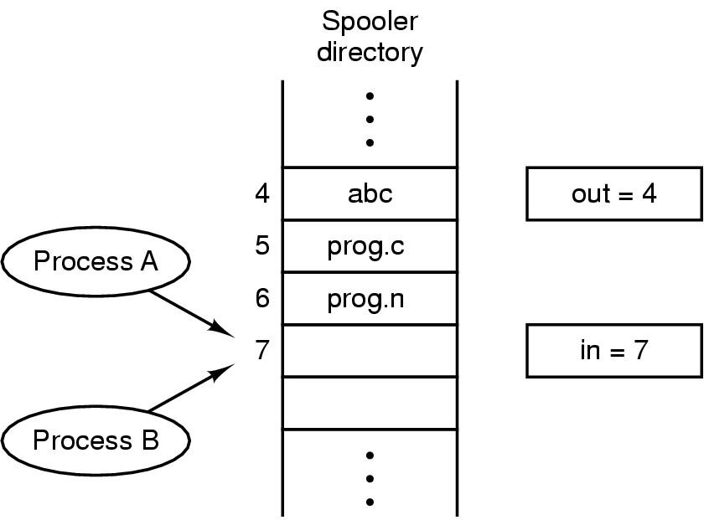
Definition
A race condition occurs when:
Two or more processes or threads access and modify a shared resource at the same time, and the final result depends on the order of execution.
If execution order changes, the result may change.
This leads to unpredictable and incorrect behavior.
Example of Race Condition
Suppose two processes share a variable:
balance = 1000
Both processes want to withdraw 100.
What should happen:
Final balance = 800
What may happen without protection:
Process A reads balance → 1000
Process B reads balance → 1000
Process A subtracts 100 → 900
Process B subtracts 100 → 900
Final balance = 900 (incorrect)
The correct result should be 800.
The error happened because both processes accessed and modified the shared variable at the same time.
This is a race condition.
10.3 Critical Regions (Critical Sections)
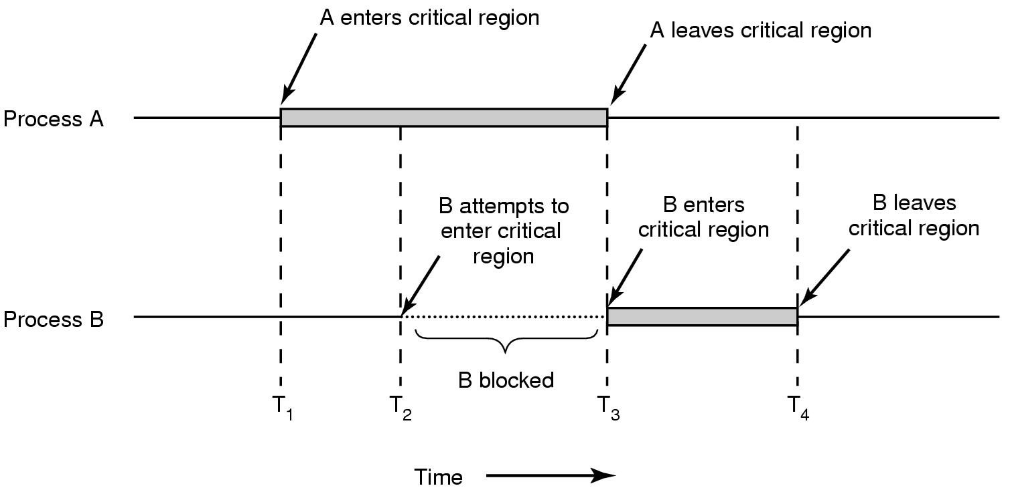
Definition
A critical region (or critical section) is a part of a program where:
- A shared resource is accessed.
- Only one process or thread should execute that part at a time.
Example:
In the bank example, the code that updates balance is the critical region.
Why Critical Regions Are Needed
Critical regions are needed to:
- Prevent race conditions
- Protect shared data
- Ensure correct results
- Maintain data consistency
If multiple processes enter the critical region simultaneously, data corruption may occur.
So we must ensure mutual exclusion.
10.4 Requirements for Mutual Exclusion
To solve the critical region problem correctly, the solution must satisfy four conditions.
1. No Two Processes in Critical Region Simultaneously
At any moment:
- Only one process may execute inside the critical region.
This ensures shared data is safe.
2. No Assumptions About CPU Speeds or Number of CPUs
The solution must work regardless of:
- Fast or slow processors
- Single-core or multi-core systems
Correctness should not depend on hardware speed.
3. No Process Outside Its Critical Region Should Block Others
A process that is not trying to enter the critical region:
- Must not prevent others from entering.
This avoids unnecessary blocking.
4. No Starvation (No Process Must Wait Forever)
If a process wants to enter the critical region:
- It should eventually be allowed to enter.
- It must not wait forever.
This ensures fairness.

11. Mutual Exclusion Techniques
To prevent race conditions, we use mutual exclusion techniques.
These techniques ensure that:
Only one process or thread can enter the critical region at a time.

11.1 Disabling Interrupts
Idea
When a process enters the critical region:
- It disables interrupts.
- No context switch can occur.
- It finishes the critical section.
- Then it enables interrupts again.
How It Works
If interrupts are disabled:
- The CPU cannot switch to another process.
- The current process runs without interruption.
- No other process can enter the critical region.
Advantages
- Very simple.
- Works well inside the kernel.
Disadvantages
- Not suitable for user-level programs.
- If a process forgets to enable interrupts, the system may hang.
- On multiprocessor systems, disabling interrupts on one CPU does not stop others.
Therefore, this method is mainly used inside the operating system kernel, not in user programs.
11.2 Lock Variables
Idea
Use a shared variable (lock) to control access.
Example:
lock = 0 → critical region is free
lock = 1 → critical region is busy
Before entering the critical region:
- A process checks if lock == 0.
- If yes, it sets lock = 1 and enters.
- After leaving, it sets lock = 0.
Problem
This method is not safe because:
Two processes might check lock at the same time.
Example:
- Process A sees lock = 0.
- Process B also sees lock = 0.
- Both set lock = 1.
- Both enter the critical region.
This causes a race condition.
So simple lock variables are not a complete solution.
11.3 Strict Alternation
Idea
Processes take turns entering the critical region.
A shared variable "turn" is used.
If turn = 0 → Process 0 enters
If turn = 1 → Process 1 enters
After finishing:
- Process 0 sets turn = 1.
- Process 1 sets turn = 0.
Advantage
- Prevents two processes from entering at the same time.
Problem
It violates one condition of mutual exclusion:
A process outside the critical region may block another.
Example:
- Process 0 is not interested in entering.
- But turn = 0.
- Process 1 must wait unnecessarily.
This causes unnecessary blocking.
So strict alternation is not an ideal solution.

12. Making Single-Threaded Code Multithreaded
When converting a single-threaded program into a multithreaded program, new problems arise.
12.1 Problems with Global Variables
In a single-threaded program:
- Global variables are safe.
- Only one execution path modifies them.
In a multithreaded program:
- Multiple threads can access global variables simultaneously.
- This may cause race conditions.
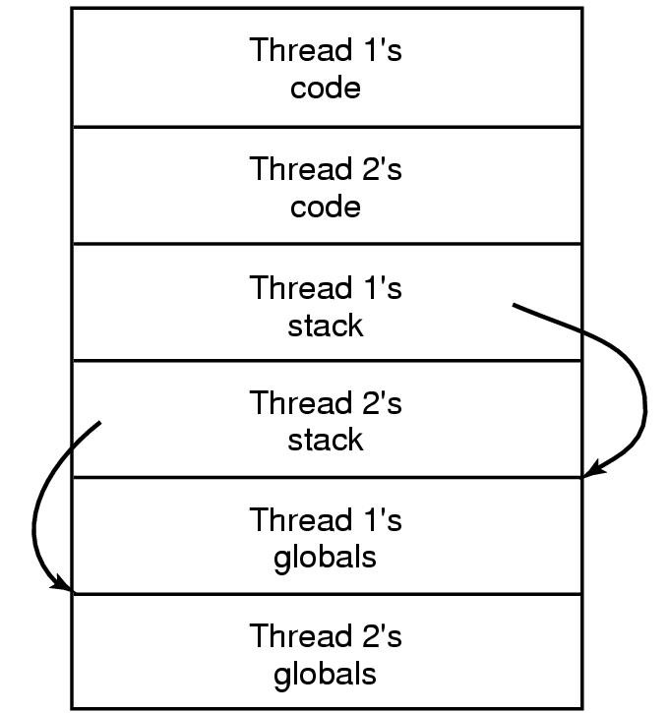
Example:
global counter = 0
Thread A increments counter.
Thread B increments counter at the same time.
Final value may be incorrect due to overlapping execution.
This makes global variables dangerous in multithreaded programs.
12.2 Thread-Private Data
To solve problems with global variables:
Each thread can have its own private data.
Thread-private data means:
- Each thread has its own copy of a variable.
- Other threads cannot access it.
Example:
Instead of using one global counter:
Each thread maintains its own local counter.
This prevents interference between threads.
It improves safety and reduces synchronization needs.

